OXIDATION AND REDUCTION 12

Redox Reactions

1. Oxidation occurs when

a) a substance donates hydrogen ions.
b) a substance becomes negatively charged.
c) a substance gives up electrons.
d) a substance gains electrons.

2. In which one of the following examples is bromine reduced?

a) 2Br⁻(aq) + Cl₂(g)  Br₂(aq) + 2Cl⁻(aq)
b) Br₂(l) + 2I⁻(aq) 2Br⁻(aq) + I₂(s)
c) NaBr(s) Na⁺(aq) + Br⁻(aq)
d) Pb²⁺(aq) + 2Br⁻(aq) PbBr₂(s)

3. A redundant (reducing agent) is a substance which

a) readily gives up electrons.
b) is easily reduced.
c) gives up hydrogen ions.
d) is highly electronegative.

4. Which one of the following is NOT an oxidising agent?

a) Chlorine.
b) Oxygen.
c) Zinc.
d) Concentrated sulfuric acid.

5. What is the oxidation number of manganese in the permanganate ion, MnO₄⁻?

a) –1 b) +7
c) -7 d) +8

The next three questions refer to the equation below:

6Fe²⁺ + 8HNO₃ ☑ 6Fe³⁺ + 2NO + 4H₂O + 6NO₃⁻

6. The substance oxidised is

a) Fe²⁺
b) HNO₃
c) Fe³⁺
d) NO

7. The oxidising agent is

a) Fe²⁺
b) HNO₃
c) Fe³⁺
d) NO

8. The oxidation numbers of nitrogen in HNO₃, NO and NO₃⁻ are

a) –1, +2 and +5 respectively
b) –5, +2 and –5 respectively.
c) +5, +2 and +5 respectively.
d) +5, +4 and +5 respectively.

The next five questions refer to the following unbalanced equation, which shows the redox reaction between chlorine dioxide and iodide ion in acid solution:

ClO₂ + H⁺ + I⁻ ☑ I₂ + Cl⁻ + H₂O

9. Which substance is oxidised?

a) Iodine.
b) Chlorine dioxide.
c) Iodide ion.
d) Hydrogen ion.

10. Which substance is the oxidising agent?

a) Chlorine dioxide.
b) Iodide ion.
c) Hydrogen ion.
d) Iodine.

11. How many electrons are given up per ion or molecule of the substance oxidised?

a) 1 b) 2
c) 3 d) 4

12. How many electrons are accepted per ion or molecule of the substance reduced?

a) 2 b) 3
c) 4 d) 5

13. If the above equation is balanced , the coefficients needed are:

a) 1, 8, 10, 5, 1, 2.
b) 2, 8, 10, 5, 2, 4.
c) 2, 16, 10, 5, 4, 4.
d) 1, 8, 10, 5, 4, 4.

14. Which one of the following is NOT a redox reaction?

a) 2Mg(s) + O₂(g) 2MgO(s)
b) Zn(s) + Cu²⁺(aq) Zn²⁺ + Cu(s)
c) Ag⁺(aq) + Cl⁻(aq) AgCl(s)
d) 2Ag(s) + S(s) Ag₂S(s)

15. What is the product formed when Cu⁺ ions are reduced?

a) Cu(s) b) Cu²⁺
c) Cu⁻ d) Cu²⁻

16. All of the following are good oxidising agents with the exception of

a) permanganate ion, MnO₄⁻
b) chlorine.
c) nitric acid, HNO₃
d) oxalate ion, C₂O₄²⁻

17. What would you expect to observe when chlorine is added to a solution of sodium bromide.

a) The solution would turn red.
b) A purple precipitate would be formed.
c) There would be no reaction.
d) The solution would become green.

18. A substance which simultaneously oxidises and reduces itself is said to undergo a type of reaction known as

a) hydrolysis.
b) disproportionation.
c) displacement.
d) neutralisation.

19. Which one of the following equations shows disproportionation?

a) 2H₂O₂(aq)  2H₂O(l) + O₂(g)
b) Zn(s) + Cu²⁺(aq) Zn²⁺(aq) + Cu(s)
c) MnO₄⁻(aq) + 8H⁺(aq) + 5Fe²⁺(aq) Mn²⁺(aq) + 4H₂O + 5Fe³⁺(aq)
d) 2Br⁻(aq) + Cl₂(g) Br₂(l) + 2Cl⁻(aq)

20. Which one of the following is a strong oxidising agent, used both as a bleaching agent and in the purification of water?

a) Hydrogen peroxide, H₂O₂.
b) Hypochlorite ion, OCl⁻.
c) Hydrogen chloride, HCl.
d) Sulfuric acid, H₂SO₄.

21. Study the following equation for the reaction between concentrated nitric acid and copper metal and then answer the question below.

Cu(s) + 4H⁺(aq) + 2NO₃⁻(aq) Cu²⁺(aq) + 2H₂O(l) + 2NO₂(g)

The reducing agent is

a) copper metal.
b) nitric acid.
c) hydrogen ions.
d) nitrogen doxide.

22. Which one of the following correctly shows the substances listed in order of increasing strength as reducing agents?

a) F⁻, Al, Zn, Cu, I⁻
b) I⁻, F⁻, Zn, Al, Cu.
c) F⁻.I⁻, Cu, Al, Zn.
d) F⁻, I⁻, Cu, Zn, Al.

Electrochemical Cells

23. Which one of the following statements is FALSE?

a) In an electrochemical cell, chemical energy is converted to electrical energy.
b) Oxidation occurs at the anode and reduction at the cathode in both an electrochemical cell and an electrolytic cell.
c) In an electrolytic cell, an external source of electricity is used to drive the reaction.
d) In an electrochemical cell, the anode is positively charged.

The next five questions refer to the diagram below showing an electrochemical cell.
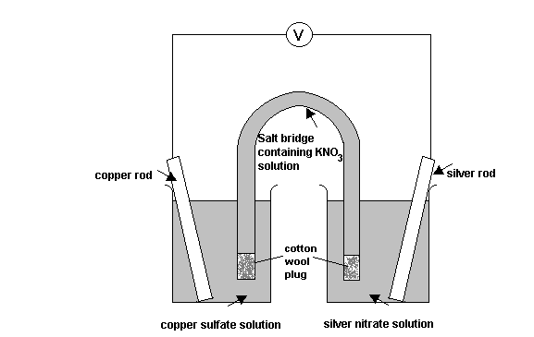

24. What is the substance oxidised in the above cell?

a) Potassium ions.
b) Nitrate ions.
c) Silver.
d) Copper.

25. The substance reduced in the above cell is

a) the copper ions.
b) the silver ions.
c) silver.
d) the potassium ions.

26. What is the anode in this cell and in which direction do the electrons flow in the external circuit?

a) The anode is the silver rod and the electrons flow from the silver rod to the copper rod.
b) The anode is the silver rod and the electrons flow from the copper rod to the silver rod.
c) The anode is the copper rod and the electrons flow from the copper rod to the silver rod.
d) The anode is the copper rod and the electrons flow from the silver rod to the copper rod.

27. What is the voltage (EMF) of the above cell?

a) +0.34 volts.
b) +0.80 volts.
c) +0.46 volts.
d) –0.46 volts.

28. What is the function of the salt bridge in an electrochemical cell such as the one above?

a) To allow the movement of ions between the two half-cells to maintain electrical neutrality.
b) To supply the ions necessary for oxidation and reduction.
c) To allow the electrons to move from the anode to the cathode.
d) To keep the level of the solutions equal in both half-cells.

29. Which one of the following equations does NOT have a positive emf?

a) Fe(s) + Cu²⁺(aq) Fe²⁺(aq) + Cu(s)
b) 2Br⁻(aq) + Cl₂(g) Br₂(l) + 2Cl⁻(aq)
c) MnO₄⁻(aq) + 8H⁺(aq) + 5Fe²⁺(aq) Mn²⁺(aq) + 4H₂O(l) + 5Fe³⁺(aq)
d) Fe(s) + Pb²⁺(aq) Fe²⁺(aq) + Pb(s)

30. Calculate the emf for the following reaction and predict whether the reaction will occur spontaneously. Assume standard conditions.

2MnO₄⁻(aq) + 16H⁺(aq) + 10I⁻(aq) 2Mn²⁺(aq) + 8H₂O(l) + 5I₂(aq)

a) The emf is +2.05volts and the reaction proceeds spontaneously.
b) The emf is –2.05 volts and the reaction does not proceed.
c) The emf is –0.97 volts and the reaction does not proceed.
d) The emf is +0.97 volts and the reaction proceeds spontaneously.

The next two questions refer to the following simple electrochemical cell.
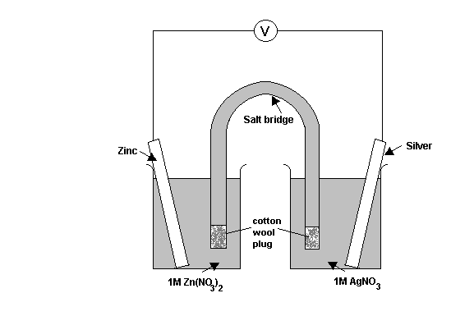
The half –cell reduction potentials are:

Zn²⁺(aq) + 2e⁻ Zn(s) emf = -0.76 volts
Ag⁺(aq) + e⁻ Ag(s) emf = +0.80 volts

31. Which one of the following reactions will occur?

a) 2Ag⁺(aq) + Zn(s) 2Ag(s) + Zn²⁺(aq)
b) Ag⁺(aq) + Zn(s) Ag(s) + Zn²⁺(aq)
c) Zn²⁺(aq) + 2Ag(s) Zn(s) + 2Ag⁺(aq)
d) Zn²⁺(aq) + Ag(s) Zn(s) + Ag⁺(aq)

32. What reading would you expect to see on the voltmeter at the start of this reaction?

a) -0.04 V.
b) +1.56 V.
c) +0.84V.
d) +2.36 V.

33. What is the primary role of manganese dioxide in the dry cell (Leclanche cell)?

a) To react and provide hydrogen ions for the redox reaction.
b) To act as the electrolyte.
c) To take part in the reduction reaction which occurs in the dry cell.
d) To act as a reducing agent.

34. Which one of the following statements about the lead-acid accumulator is false?

a) The major advantage of the lead-acid accumulator over the dry cell is that it can be
re-charged.
b) During discharge, the concentration of sulfuric acid decreases.
c) When the lead-acid accumulator is re-charging, the following reaction occurs:
Pb(s) + PbO₂(s) + 4H⁺(aq) + 2SO₄²⁻(aq) 2PbSO₄(s) + 2H₂O(l)
d) The lead-acid accumulator converts electrical energy into chemical energy during the
re-charging process.

35. To determine the reduction potential for a particular substance, it must be joined to another half-cell because oxidation and reduction must occur simultaneously.
To obtain reduction potentials, a half-cell should be connected to a ‘standard’ half-cell which acts as a common reference point. The ‘standard’ half-cell against which all others are measured is that for the

a) reduction of water to produce hydrogen gas.
b) reduction of hydrogen ions to produce hydrogen gas.
c) reduction of water from a basic solution to produce hydrogen gas.
d) oxidation of water to produce oxygen gas.

36. Rusting of iron is caused by the iron being in the presence of

a) air only.
b) water only.
c) air and water.
d) a less reactive metal.

37. Which one of these metals would not be suitable to use as a sacrificial anode to prevent the corrosion of iron?

a) Magnesium.
b) Zinc.
c) Chromium.
d) Copper.

38. Rust is thought to be

a) Hydrated iron oxide, Fe₂O₃.xH₂O
b) Iron (III) hydroxide, Fe(OH)₃.
c) Iron (II) oxide, FeO.
d) Iron (II) hydroxide, Fe(OH)₂.

39. In the extraction of iron by smelting iron ore, (Fe₂O₃) in the blast furnace, which one of the following reduces the iron oxide to iron?

a) Hydrogen.
b) Calcium carbonate.
c) Carbon dioxide.
d) Carbon monoxide.

Electrolysis

40. When an electric current is passed through a molten electrolyte, causing it to decompose, the reaction which occurs is called

a) Oxidation.
b) Reduction.
c) Electrolysis.
d) Hydrolysis.

41. Which one of the following statements is true of the anode in an electrolytic cell and the reaction that occurs there?

a) In an electrolytic cell, the anode is positive and this is where reduction occurs.
b) In an electrolytic cell, the anode is negative and this is where oxidation occurs.
c) In an electrolytic cell, the anode is positive and this is where oxidation occurs.
d) In an electrolytic cell, the anode is negative and this is where reduction occurs.

The next five questions refer to the following information and diagram.

The diagram below shows the apparatus used to electrolyse dilute solutions of silver nitrate, (using inert carbon electrodes) and copper sulfate (using copper electrodes).
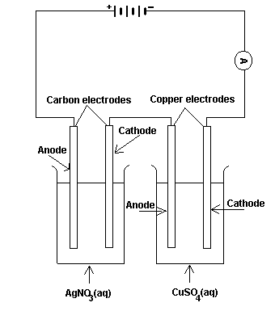
A current of 0.5 amperes was passed through the solutions for 30 minutes.
42. What substances would be formed at the silver anode and cathode respectively?

a) Anode - Oxygen gas.
Cathode - Hydrogen gas.
b) Anode - Hydrogen gas.
Cathode - Oxygen gas.
c) Anode - Oxygen gas.
Cathode - Silver metal.
d) Anode - Silver metal.
Cathode - Oxygen gas.

43. What substances would be formed at the copper anode and cathode respectively?

a) Anode - Oxygen gas.
Cathode - Copper metal.
b) Anode - Copper metal.
Cathode - Oxygen gas.
c) Anode - Copper ions.
Cathode - Copper metal.
d) Anode - Copper metal.
Cathode - Copper ions.

44. What quantity of electricity passes through this electrolytic cell?

a) 6 coulombs.
b) 180 coulombs.
c) 360 coulombs.
d) 900 coulombs.

45. Using the result you obtained in question 43, calculate the number of moles of electrons that pass through this electrolytic cell.

a) 96 500 moles of electrons pass through this electrolytic cell.
b) 37.3 moles of electrons pass through this electrolytic cell.
c) 0.00933 moles of electrons pass through this electrolytic cell.
d) 0.00186 moles of electrons pass through this electrolytic cell.

46. What mass of copper metal would be deposited in the copper – copper sulfate cell?

a) 0.00184 g b) 0.296 g
c) 0.00186 g d) 0.00373 g

The following three questions are based on the following information.

The diagram below shows the apparatus used to electrolyse a concentrated sodium chloride solution using inert electrodes.

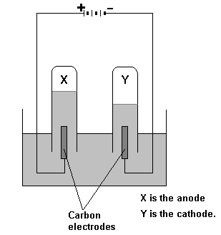

47. What gas is produced at X (anode)?

a) Oxygen.
b) Hydrogen.
c) Chlorine.
d) Water vapour.

48. The gas produced at Y (cathode) is

a) Oxygen
b) Hydrogen.
c) Chlorine.
d) Water vapour.

49. The balanced half-equation for the reaction occuring at X is

a) 2H₂O(l) O₂(g) + 4H⁺(aq) + 4e⁻
b) 2H₂O + 2e⁻ H₂(g) + 2OH⁻(aq)
c) 2Cl⁻(aq) Cl₂(g) + 2e⁻
d) H⁺(aq) + OH⁻(aq) + 2e⁻ H₂O(g)

Redox Titrations

50. Which one of the following is used as a primary standard in redox titrations?

a) Potassium permanganate.
b) Oxalic acid.
c) Hydrogen peroxide.
d) Iron (III) sulfate.

51. Which one of the following is a reason why potassium permanganate is unsuitable as a primary standard?

a) The exact molecular formula is unknown.
b) Potassium permanganate is an oxidising agent.
c) Solutions of potassium permanganate are unstable and decompose when exposed to light.
d) Its molar mass is too high.

52. In the laboratory, you would have performed the redox titration between potassium permanganate and oxalic acid. Why was the oxalic acid solution heated to approximately 80ºC before reacting it with the potassium permanganate?

a) The higher temperature favoured the oxidation of oxalic acid rather than its reduction.
b) To increase the rate of a reaction that would otherwise progress slowly at room temperature.
c) To ensure that the permanganate ion was reduced to Mn²⁺ rather than MnO².
d) To increase the solubility of the oxalic acid crystals used to make up the solution.

